A Spring MVC is a Java framework which is used to build web applications. It follows the Model-View-Controller design pattern.
It implements all the basic features of a core spring framework like Inversion of Control, Dependency Injection.
A Spring MVC provides an elegant solution to use MVC in spring framework by the help of DispatcherServlet. Here, DispatcherServlet is a class that receives the incoming request and maps it to the right resource such as controllers, models, and views.
- Model - A model contains the data of the application. A data can be a single object or a collection of objects.
- Controller - A controller contains the business logic of an application. Here, the @Controller annotation is used to mark the class as the controller.
- View - A view represents the provided information in a particular format. Generally, JSP+JSTL is used to create a view page. Although spring also supports other view technologies such as Apache Velocity, Thymeleaf and FreeMarker.
- Front Controller - In Spring Web MVC, the DispatcherServlet class works as the front controller. It is responsible to manage the flow of the Spring MVC application.

Understanding the flow of Spring Web MVC

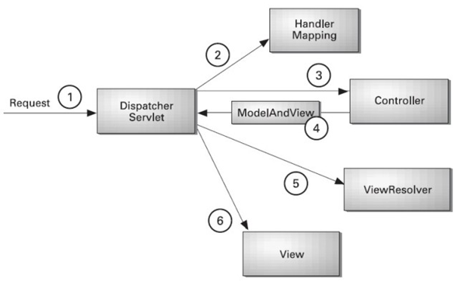

All the incoming requests are intercepted by DispatcherServlet that works as a front controller.
The DispatcherServlet gets an entry of handler mapping from the XML file and forwards the request to the controller.
The controller returns an object of ModelAndView.
The DispatcherServlet checks the entry of view resolver in the XML file and invokes the specified view component.

